IOT BASED SOLAR POWERED SMART AGRICULTURE MONITORING SYSTEM
Badugu Sai Ramya¹,Anantoju Tarun²,Baikadi Nandini³, Hegdapure Sachin⁴ , Dr.Rajesh Durgam⁵
¹20Q91A0452 Student, Electronics and Communications Engineering, Malla Reddy College of Engineering
²20Q91A0454 Student, Electronics and Communications Engineering, Malla Reddy College of Engineering
³20Q91A0422 Student, Electronics and Communications Engineering, Malla Reddy College of Engineering
⁴20Q91A0457 Student, Electronics and Communications Engineering, Malla Reddy College of Engineering
⁵Associate Professor, Electronics and Communications Engineering , Malla Reddy College of Engineering
---------------------------------------------------------------------***---------------------------------------------------------------------
Abstract -Crop farming in India is labour intensive and obsolete. Farming is still dependent on techniques which were evolved hundreds of years ago and does not take care of conservation of resources. The newer scenario of decreasing water tables, drying up of rivers and tanks, unpredictable environment presents an urgent need of proper utilization of water. We have the technology to bridge the gap between water usage and water wastage. Technology used in some developed countries is too expensive and complicated for a common farmer to understand. Our project is to give cheap, reliable, cost efficient and easy to use technology which would help in conservation of resources such as water and also in automating farms.
Key Words: Arduino UNO, IOT,Temperature and Humidity sensor, soil Moisture sensor,IR Sensor,Water level Indicator,WIFI Module

1.INTRODUCTION
Agriculture is major source of income for the largest population in India and is major contributor to Indian economy. In past decade it is observed that there are not much crop development in agriculture sector. Food prices are continuously increasing because crop rate declined. There are number of factor which is responsible for this it may be due to water waste, low soil fertility, Fertilizer abuse, climate change or diseases etc. It is very essential to make effective intervention in agriculture and the solution is IOT in integration with wireless sensor network. Internet of things (IOT) is a method of connecting everything to the internet- it is connecting object or things(such as car, home, electronic devices, etc. ...) which are previously not connected with each other main purpose of IOT is ensuring delivery of right information to right people at right time. In agriculture irrigation is the important factor as the monsoon rain falls are unpredictable and uncertain.
An embedded system is a computer system designed to perform one or a few dedicated functions often with real-time computing constraints. It is embedded as part of a complete device often including hardware and mechanical parts. By contrast, a general-purpose computer, such as a personal computer (PC), is designed to be flexible and to meet a wide range of end-user needs. Embedded systems control many devices in common use today. Embedded systems are controlled by one or more main processing cores that are typically either micro controllers or digital signal processors (DSP). The key characteristic, however, is being dedicated to handle a particular task, which may require very powerful processors. For example, air traffic control systems may usefully be viewed as embedded, even though they involve mainframe computers and dedicated regional and national networks between airports and radar sites. (Each radar probably includes one or more embedded systems of its own).

2. EXISTING METHOD
The existing method and one of the oldest ways in agriculture is the manual method of checking the parameters. In this method farmers they themselves verify all the parameters and calculate the reading. Farmers used to guess the fertility of the soil and assumed to grow which type of crop. They didn’t know about the moisture, level of water, and particularly weather condition which terrifies a farmer more. They use pesticides based on some assumptions which made leads to a serious effect on the crop if the assumption is wrong. The productivity depends on the final stage of the crop on which the farmer depends.
Drawbacks of Existing Method
- Productivity may or may not be more
- We cannot estimate weather conditions as pollution is increasing gradually etc.
- There is no proper crop protection.
- No natural renewable energy can be used to crops.
- No indication system for farmer.

3. PROPOSED METHOD
Monitoring agricultural environment for various factors such as temperature and humidity along with significance to protect the crops from environmental heavy rain, heavy sun rays, heavy chemical industries pollution's, and fire detection to the crop with help of sensors where farmer can get update of the field. It focuses on developing devices and tool to manage, display and alert the users using the advantages of a wireless sensor network system. It aims at making agriculture smart using automation and IOT technologies.
It proposes a low cost and efficient wireless sensor network technique to acquire from different sensors. As per need of the crop controller to take decision whether the irrigation is enabled or not.
It proposes an idea about how automated irrigation system was developed to optimize water use for agriculture .The system is also equipped with solar panel which provides power backup to the system in the absence of power supply.
There is a real time display system which displays information collected by all sensors along with decision/action taken by micro-controller over internet. It has a provision of automatic and manual operation of relay using switches, provided on control panel over internet which can be accessed from anywhere in the world.

4.BLOCK DIAGRAM
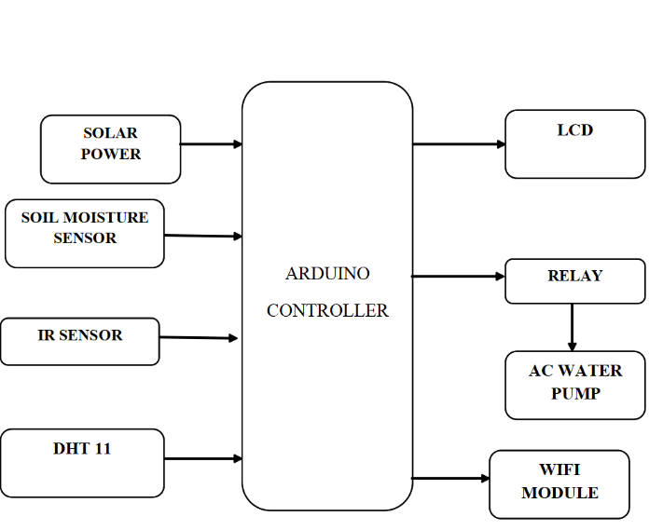
Fig.1: Block Diagram of proposed method
SOIL MOSITURE SENSOR
Soil moisture sensors may be wired or wireless. In smart agriculture systems, wireless sensors are often preferred for easy deployment and data collection. These sensors transmit data to a central control system or a cloud-based platform.Soil moisture sensors are typically inserted into the ground at various depths, depending on the rooting depth of the crops. Probes or rods are commonly used to ensure proper contact with the soil.The LM324 series consists of four independent, high gains; internally frequency compensated operational amplifiers which were designed specifically to operate from a single power supply over a wide range of voltages. Operation from split power supplies is also possible and the low power supply current drain is independent of the magnitude of the power supply voltage.
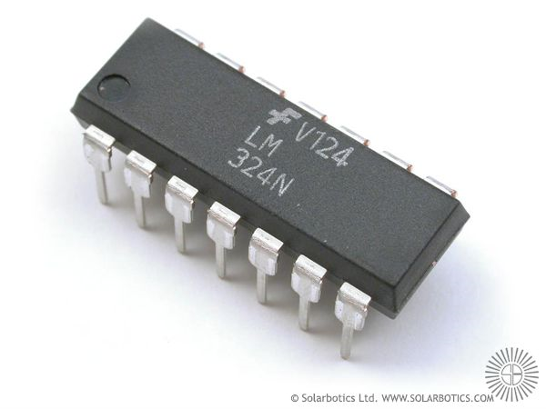
Fig.2:.soil moisture sensor LM324

IR SENSOR
An electro-luminescent IR LED is a product which requires care in use. IR LED’s are fabricated from narrow band hetero structures with energy gap from 0.25 to 0.4 eV. Infra red transmitter emits IR rays in planar wave front manner. Even though infrared rays spread in all directions, it propagates along straight line in forward direction. IR rays have the characteristics of producing secondary wavelets when it collides with any obstacles in its path. This property of IR is used here.
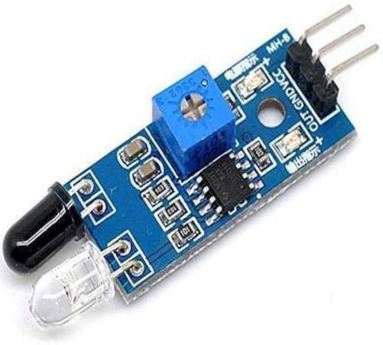
Fig.3: IR Sensor
DHT11
The DHT11 is a commonly used Temperature and humidity sensor. The sensor comes with a dedicated NTC to measure temperature and an 8-bit micro controller to output the values of temperature and humidity as serial data. The sensor is also factory calibrated and hence easy to interface with other micro controllers.The sensor can measure temperature from 0°C to 50°C and humidity from 20% to 90% with an accuracy of ±1°C and ±1%.
LCD(LIQUID CRYSTAL DISPLAY)
One of the most common devices attached to a micro controller is an LCD display. Some of the most common LCD’s connected to the many micro controllers are 16x2 and 20x2 displays. This means 16 characters per line by 2 lines and 20 characters per line by 2 lines, respectively.
Basic 16x 2 Characters LCD
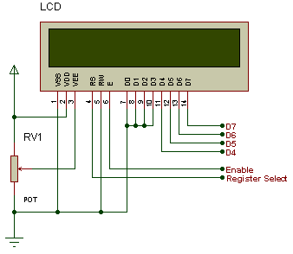
Fig.4: PIN Diagram of LCD
RELAY
A Relay is a simple electromechanical switch. While we use normal switches to close or open a circuit manually, a Relay is also a switch that connects or disconnects two circuits. But instead of a manual operation, a relay uses an electrical signal to control an electromagnet, which in turn connects or disconnects another circuit.
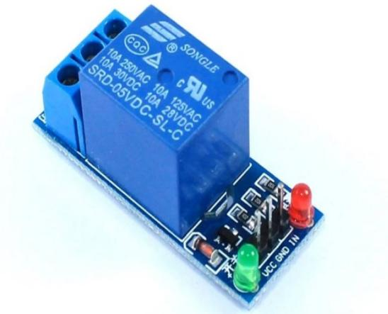
Fig.5: Relay
WIFI MODULE
WiFi modules or WiFi micro controllers are used to send and receive data over Wi-Fi. They can also accept commands over the Wi-Fi. Wi-Fi modules are used for communications between devices. They are most commonly used in the field of Internet of Things.
ADVANTAGES
- Precision Farming
- Real-Time Monitoring
- Weather Forecasting Integration
- Crop Monitoring and Management
- Early Detection of Issues
- Enhanced Sustainability
RESULT
Generally, a moisture/temperature range which is already specified in data sheet of module, and whenever the actual values are out of this range, the micro controller automatically turn ON the water pump, which is mounted on at output pins. The micro controller also has solenoid valve attached to it to make sure that the pipes are actually watering the fields uniformly so that no area gets clogged or is left too dry. The entire system can be monitored by the end-user through a TELNET and Telegram application. Smart irrigation system makes it possible for farmers to monitor and irrigate their fields remotely, without any hassles.

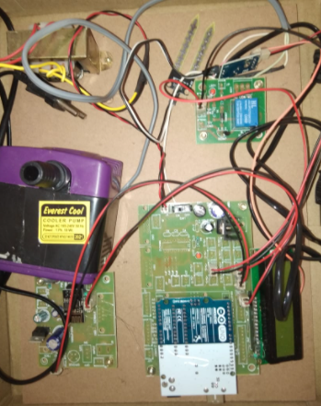
Fig.6.1: Hardware kit

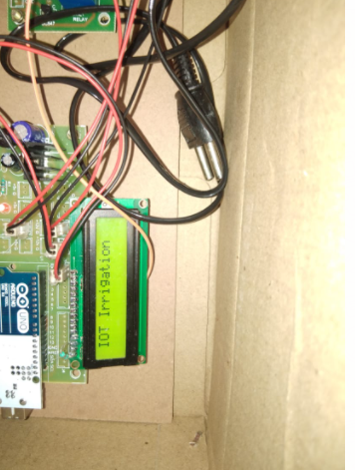
Fig.6.2: IOT Irrigation Display

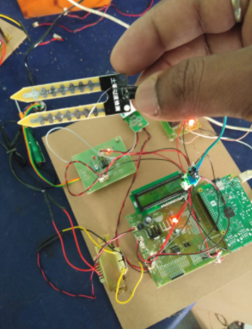
Fig.6.3:Soil Moisture Sensor

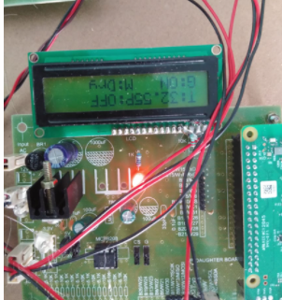
Fig.6.4:Displaying Input Parameters in LCD

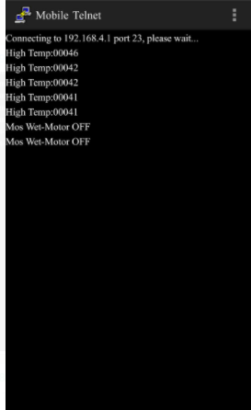
Fig.6.5: Output Results

FUTURE SCOPE
For further enhancement, this system is used for large acres of land. Also, the system can be integrated to check the soil nutrient and crop growth in each soil. Also, the system can be further improved by adding machine learning algorithms, which are able to learn and understand the requirements of the crop, this would help the field be an automatic system.
CONCLUSION
Internet of Things will help to enhance smart farming. Using IoT we can predict the soil moisture level and humidity. Irrigation system can be monitored and controlled by IoT technology. The crop damage using predators is reduced. IoT works in different domains of farming to improve time efficiency, water management, crop monitoring, soil management, control of insecticides and pesticides. It also minimizes human efforts, simplifies techniques of farming and helps to gain smart farming. Along with these features smart farming can help to grow the market for farmer with single touch and minimum efforts.
REFERENCES
[1]. Rajalakshmi.P, Mrs.S.Devi Mahalakshmi “IOT Based Crop-Field Monitoring And Irrigation Automation” 10th International conference on Intelligent systems and control (ISCO), 7-8 Jan 2016 published in IEEE Explore Nov 2016.
[2]. Prof. K. A. Patil And Prof N. R. Kale proposes “A Model For Smart Agriculture Using IOT” 2016 International Conference on Global Trends in signal Processing, Information Computing And Communication.
[3]. Dr.N.Suma, Sandra Rhea Samson, S. Saranya, G. Shanmugapriya, R. Subhashri „IOT Based Smart Agriculture Monitoring System‟ 2017 International Journal on Recent and Innovation Trends in Computing and Communication.
[4]. Mahammad shareef Mekala, Dr.P.Viswanathan „A Survey: Smart agriculture IoT with cloud Computing ‟ 978-1-5386-1716-8/17/$31.00 ©2017 IEEE
[5]. Prathibha S R1, Anupama Hongal 2, Jyothi M P3‟ IOT BASED MONITORING SYSTEM IN SMART AGRICULTURE‟ 2017 International Conference on Recent Advances in Electronics and Communication Technology
[6]. Ibrahim Mat, Mohamed Rawidean Mohd Kassim, Ahmad Nizar Harun, Ismail Mat Yusoff “IOT in Precision Agriculture Applications Using Wireless Moisture Sensor Network” 2016 IEEE Conference on Open Systems (ICOS), October 10-12- 2016, Langkaw, Malaysia.
[7]. Zhaochan Li, JinlongWang, Russell Higgs, LiZhou WenbinYuan4 “Design of an Intelligent Management System for Agricultural Green houses based on the Internet of Things” IEEE International Conference on Embedded and Ubiquitous Computing (EUC) 2017.
[8]S. R. Nandurkar, V. R. Thool, “Design and Development Precision Agriculture System Using Wireless Sensor Network”, IEEE International Conference on
Automation, Control, Energy and Systems(ACES),2014
[9] JoaquinGutierrez, Juan Francisco Villa-Medina, Alejandra Nieto-Garibay, and Miguel Angel Porta-Gandara,“Automated Irrigation System Using a Wireless Sensor Network and GPRS Module”, IEEE TRANSACTIONS ON INSTRUMENTATION AND MEASUREMENT,0018-9456,2013
[10] Dr. V. Vidya Devi, G. Meena Kumari, “Real- Time Automation and Monitoring System for Modernized Agriculture” , International Journal of Review and Research in Applied Sciences and Engineering (IJRRASE) Vol3 no.1. pp 7-12,2013

